Instructions for Changing AS400 Password
Login using the MCH temporary password
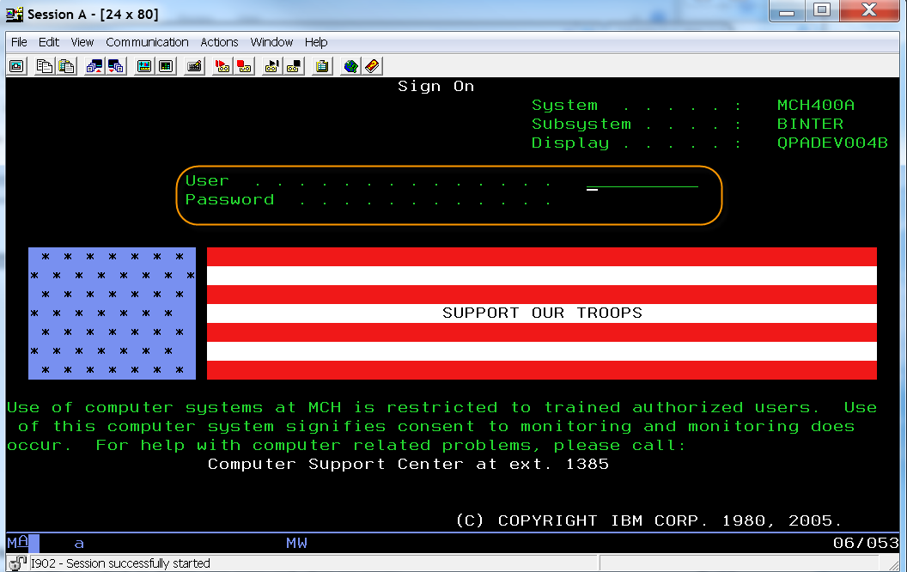
Hit the F9 key
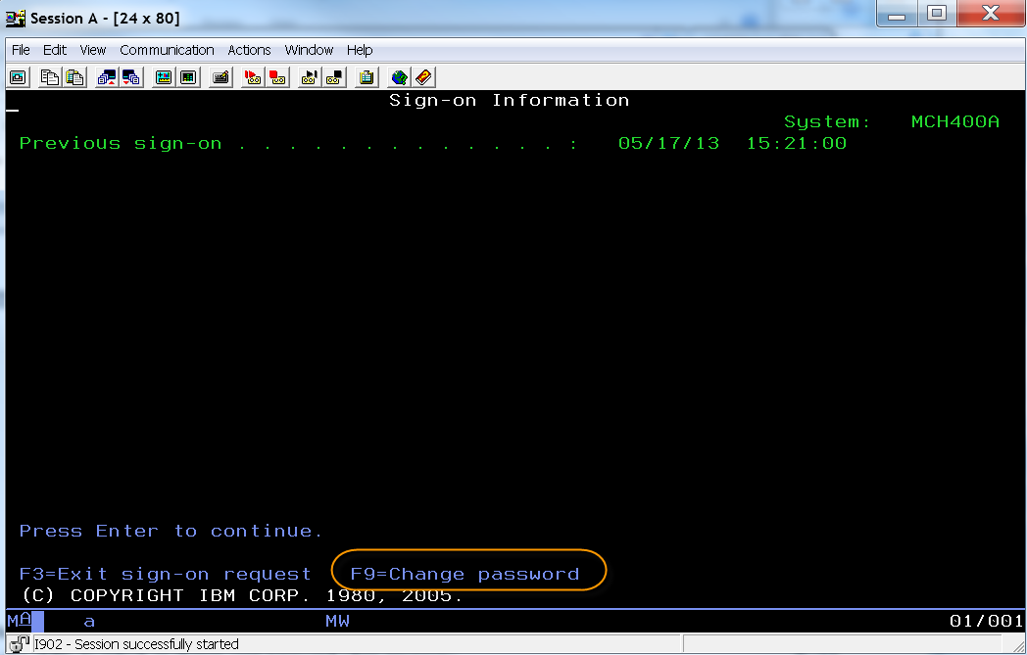
The Current password is the MCH Temporary password
Password needs to be the same as your MCHlogin password for Citrix
